Procedure for Simplifying Contract Search in eMarketplace

From the DGS Procurement web site (www.dgs.state.pa.us/procurement), select the eMarketplace link. You can also get to eMarketplace by entering in the address bar, www.emarketplace.state.pa.us.

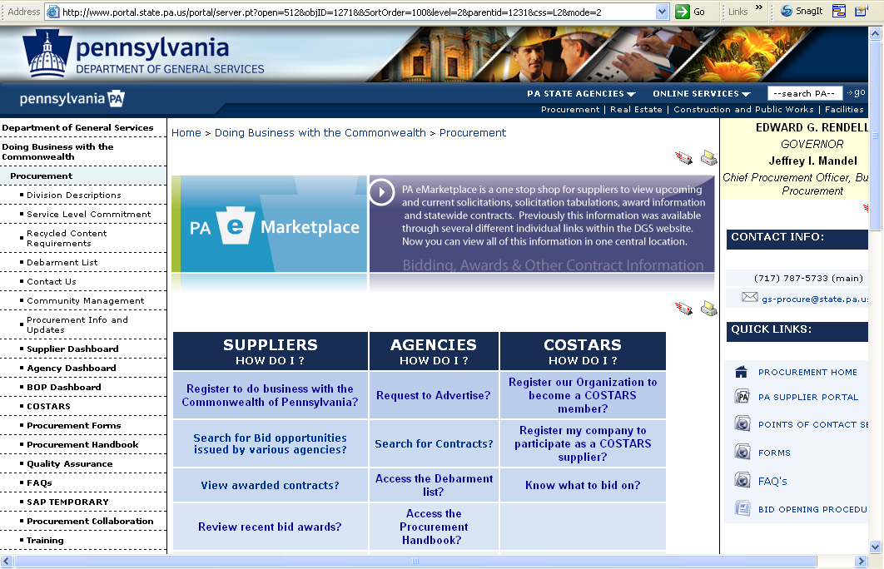

Once in the eMarketplace web site, select Search Contracts button.
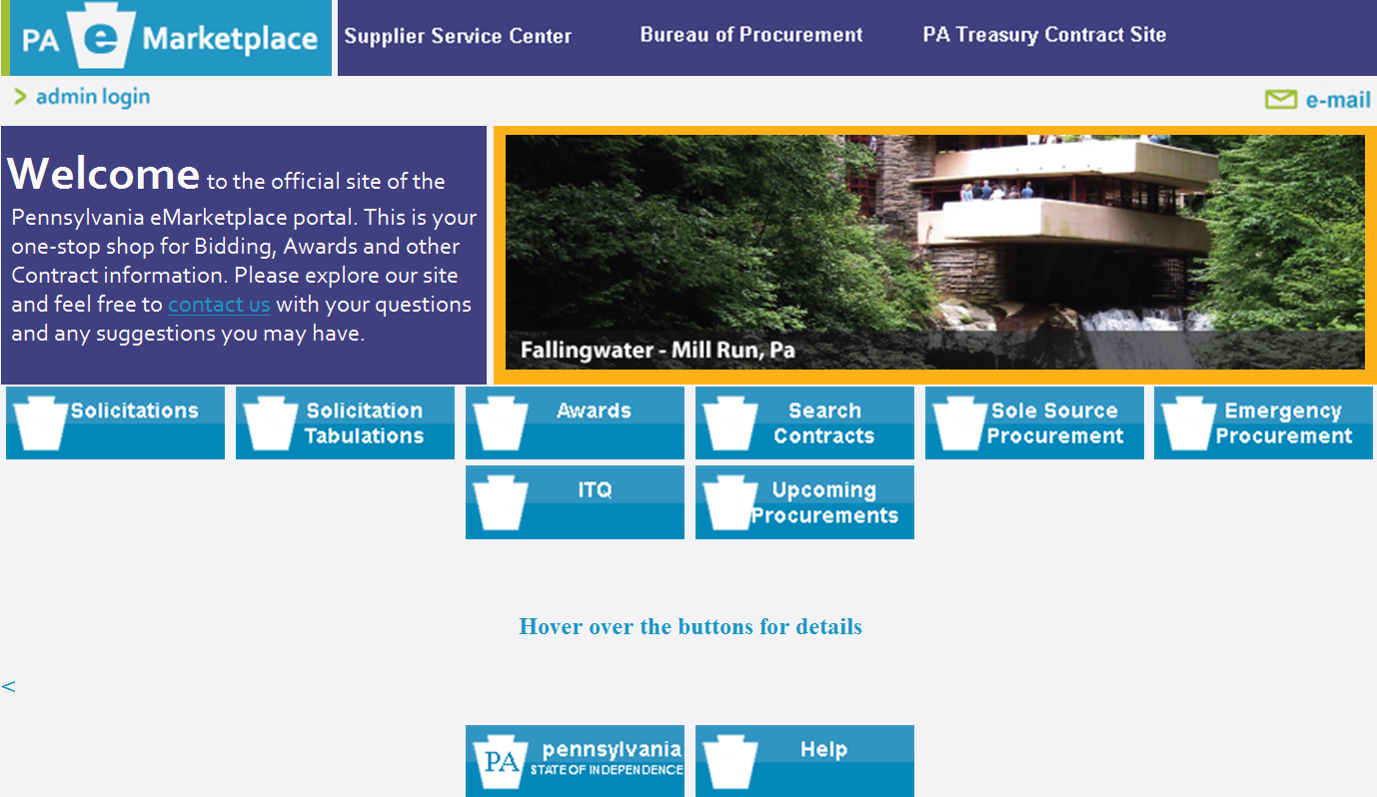

In the Select Contracts screen, select the View List of Contracts link at the top of the page.

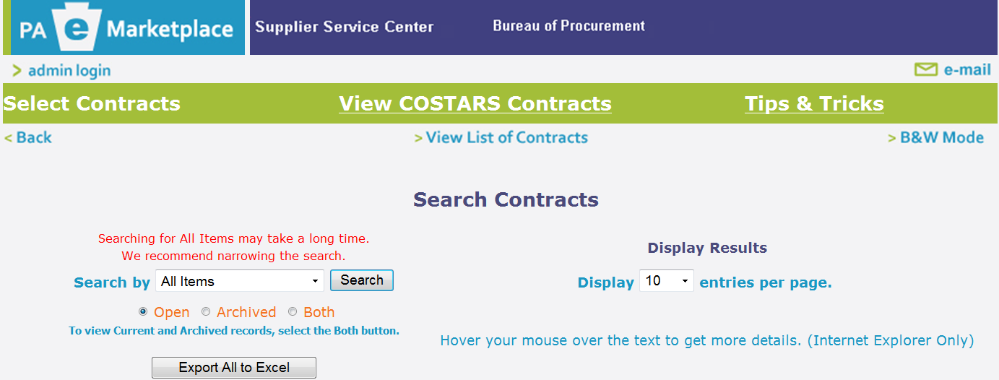

A list of all contracts will display by Parent Number, Description, and Ending Date. You can sort by any of these fields by selecting the word at the top of the column. You can search for your contracts here, or Export to Excel for easier sorting and searching capabilities.

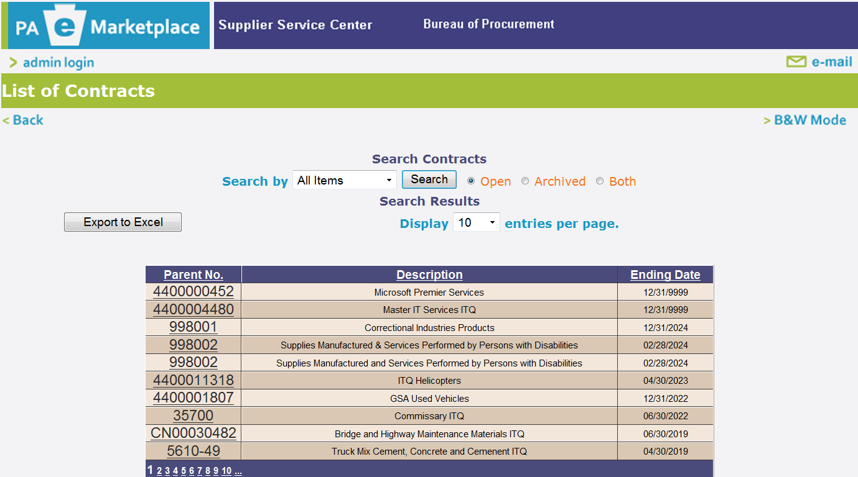

If you Export to Excel, a dialog box will appear. Select Open.

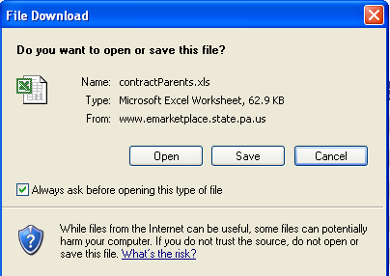

The list of contracts will display in the spreadsheet as shown below.
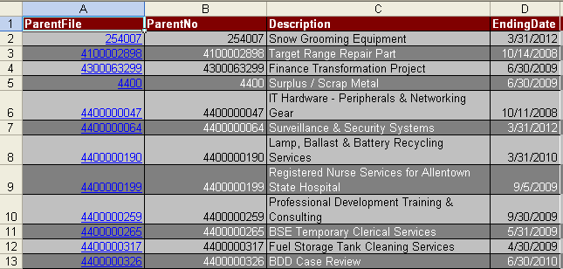

Select Find & Select button and Select Find from the top menu bar to search for specific contracts.

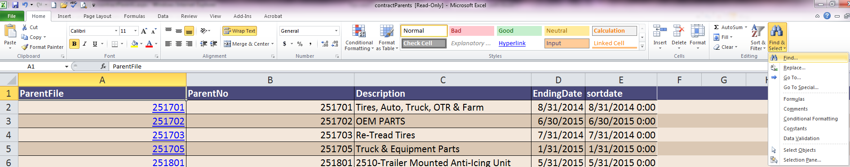

Enter your search criteria in the Find what space and select the Find Next button. Contracts fitting your criteria will be highlighted on the spreadsheet as shown below. To view the vendors’ contracts for that parent contract, select the “blue” highlighted numbers under the Parent column.

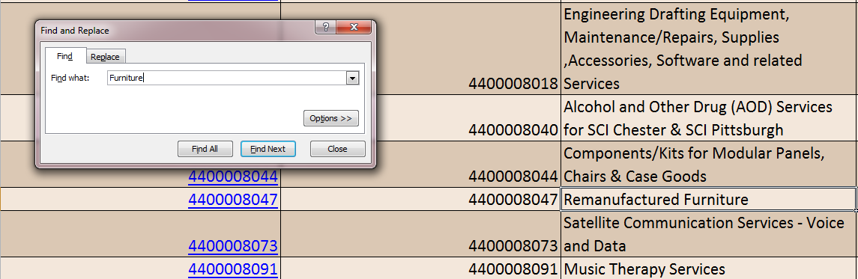

This will take you back into eMarketplace. Select the Search button to view the Parent contract you selected.
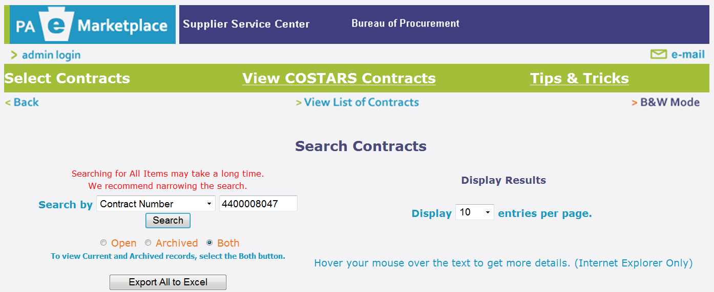

A list of contracts displays that belong to the Parent contract you selected.
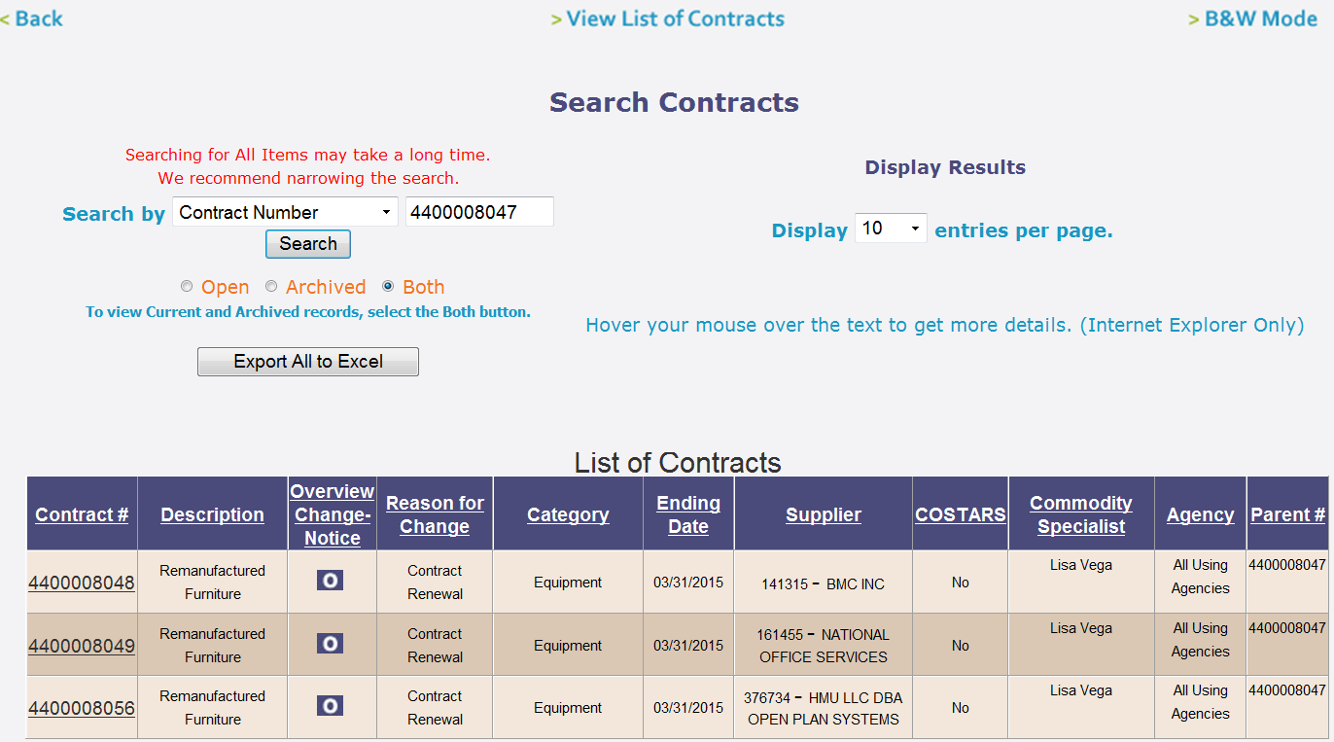

END

