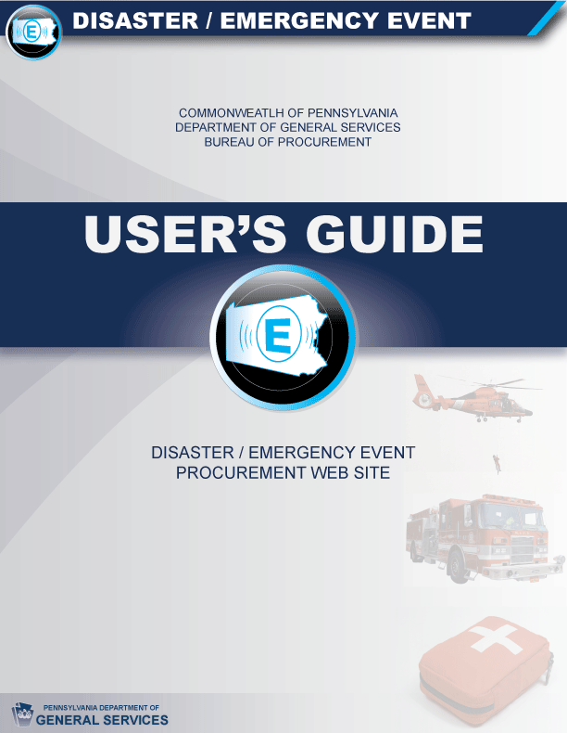
TABLE OF CONTENTS

- INTRODUCTION 3-4
- WEBSITE OVERVIEW 5-6
- PROCUREMENT FLOW CHART FOR DISASTER/EMERGENCY EVENTS 7-9
- PURCHASE ORDER FORM FOR DISASTER/EMERGENCY
EVENTS 10-13
- LISTS OF PRE-QUALIFIED AND KNOWN SUPPLIERS 14
  - MATERIALS 15-17
  - SERVICES 18-19
  - RAW MATERIALS 20
  - COSTARS 21-22
  - GSA 23-24
- DGS/ BOP POINTS OF CONTACT 25
- RELATED LINKS 26
APPENDIX A – HOW TO INSTALL DISASTER EMERGENCY WEBSITE ICON 28-35
APPENDIX B – EXCEL SPREADSHEET TERMINOLOGY 36
APPENDIX C – HOW TO USE THE FIND TOOL 37
APPENDIX D – HOW TO SORT CELLS 38-40
APPENDIX E – HOW TO FILTER CELLS 41-43
APPENDIX F – HOW TO SEARCH IN GSA SCHEDULE 44-47
SAMPLE OF PROCUREMENT FLOW CHART 48
SAMPLE OF PURCHASE ORDER FORM 49-50
I. INTRODUCTION

Purpose:
    - This User’s Guide provides general information and instruction on how to procure materials and services during a disaster/emergency event using the Commonwealth of Pennsylvania (CWOPA) Department of General Services (DGS) Bureau of Procurement (BOP) Disaster/Emergency Event Website at www.dgs.state.pa.us/disasterevent.

    - The Website is designed for those individuals who are responsible for ordering materials and services during a disaster/emergency event in the Commonwealth of PA. It is for use by state, county, city, borough, federal, military and volunteer emergency workers. The end users of this guide would include CWOPA Emergency Preparedness Liaison Officers (EPLO’s), Local Emergency Management Coordinators (EMC’s), Incident Commanders, etc.

    - The Website and User’s Guide outline the process, identify the procedures and provide the tools and resources to access suppliers and make purchases during a disaster/emergency event.

    - This User’s Guide is designed to serve as a training tool as well. Log onto the DGS Bureau of Procurement Disaster/Emergency Event Website at www.dgs.state.pa.us/disasterevent and follow the instructions in this guide. The site is available at any time for practice and training purposes. However, due to privacy and legal issues, the COSTARS spreadsheets and the list of DGS/BOP Points of Contact are only activated during actual emergency events. Further, access to the DGS/BOP Points of Contact page is limited to CWOPA EPLO’s and those with User ID’s identified by PEMA/DGS.

    - This Website does not provide an exhaustive list of suppliers for every possible requirement. It does, however, provide many reliable suppliers with emergency contact information for numerous materials and services needed during past disaster/emergency events.


    - The icon used for the DGS Bureau of Procurement Disaster/Emergency Procurement Website can be loaded onto your computer by following the instructions contained in Appendix A (How to Install Emergency Icon.)

The DGS Bureau of Procurement Disaster/Emergency Procurement Website contains:

- A Website Overview Page which outlines the process and identifies the contents of this Website.

    - A Procurement Flow Chart for Disaster/Emergency Events which provides a step-by-step diagram of the process to be used to procure materials and services during a disaster/emergency.

    - A Purchase Order Form for Disaster/Emergency Events to document and record pertinent information needed for procurement and delivery during a disaster/emergency and subsequent reconciling of funding records.

    - A List of Pre-Qualified and Known Suppliers to identify numerous suppliers for materials, services, raw materials and COSTARS. There are also links provided to search qualified suppliers on federal contracts in GSA Schedules.

    - A list of DGS/Bureau of Procurement Emergency Points of Contact to assist you in the event that you are unable to locate a supplier to fulfill your requirement. Note: Access to the DGS/BOP Points of Contact page is limited to CWOPA EPLO’s and those with User ID’s identified by PEMA/DGS.

    - This Quick Reference User’s Guide to provide information and instruction concerning the use of the DGS Bureau of Procurement Website along with disaster/emergency event policies and procedures.

    - Access to Related Links which will lead you to other websites that contain information concerning emergency response related agencies and activities.

Note: Since internet access may become a factor during an emergency, it is recommended that you print your documents and/or SAVE them to your Desktop, to a Resource Account or a Thumb Drive whenever possible.

    - Pages on the website can be printed by clicking on the print icon or by using the drop down menu.

    - Pages can be emailed by clicking on the email icon or by attaching the page as a document.

II. WEBSITE OVERVIEW
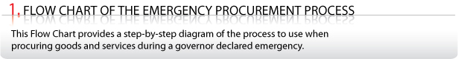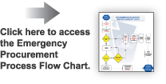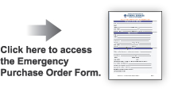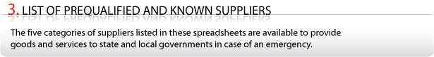
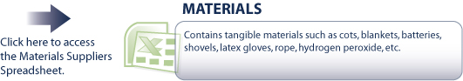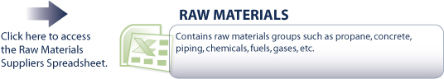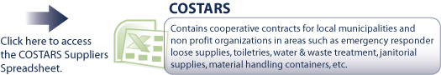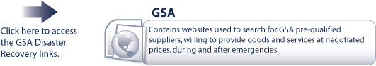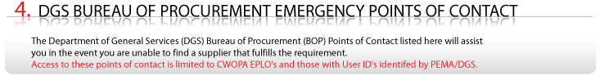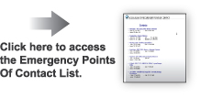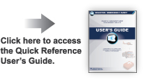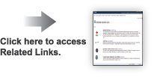

III. PROCUREMENT FLOW CHART OF
DISASTER/EMERGENCY EVENTS

Purpose:
- This flow chart provides a step-by-step diagram of the procurement process to use when buying materials and services during a disaster/emergency event.

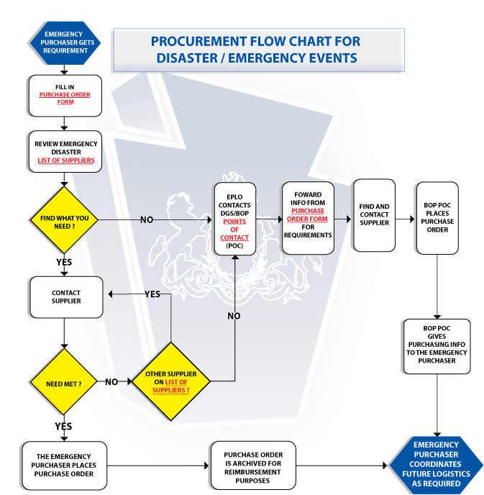

How to Use the Procurement Flow Chart for Disaster/Emergency Events

 The Process begins when the Emergency Purchaser gets a requirement.

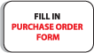The Emergency Purchaser clicks on PURCHASER ORDER FORM on the flow chart or on the Website Overview Page and begins to fill in all known and required fields. You may not be able to complete sections such as Supplier Information just yet. Simply fill out as much as you can, then proceed to the next step.

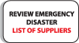The Emergency Purchaser clicks on the LIST OF SUPPLIERS on the flow chart or on the Website Overview Page. This section contains contact information for many pre-qualified and/or known CWOPA suppliers. Drilling down into these spreadsheets will give you emergency contact information provided by the suppliers for this purpose. Suppliers are grouped into 5 sections: Materials, Services, Raw Materials, COSTARS and GSA.

If you find what you need:
YES
1. Contact the supplier. 
2. Order off the website/catalogue.
3. Complete PURCHASER ORDER FORM.
4. Print the PURCHASER ORDER FORM and/or save it to the Desktop, Resource Account or Thumb Drive.
5. Ordering is now complete.
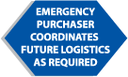 6. Emergency Purchaser coordinates future logistics as required.

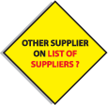 If the supplier you contact does not have what you need, try again until you find a suitable supplier to satisfy your need.

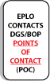
Or, click on DGS/BOP POINTS OF CONTACT and notify someone on that list of your requirement. Then proceed with steps below.

If you do not find what you need:
NO

- Click on DGS/BOP POINTS OF CONTACT
- Notify someone on that list of your requirement.
- Forward the information you have thus far from the Purchase Order Form.
- The DGS/BOP Point of Contact will locate supplier, place order and fill in remainder of the Purchase Order Form.
- DGS/BOP Point of Contact will return completed Purchase Order Form to Emergency Purchaser.
- PRINT the PURCHASER ORDER FORM and/or SAVE it to the Desktop, Resource Account or Thumb Drive.
7. Ordering is now complete.
8. The Emergency Purchaser coordinates future logistics as required.

IV. PURCHASE ORDER FORM

Purpose:

- The Purchase Order Form is completed in order to record the pertinent information needed for procurements during an emergency. This document will also be used for payment purposes.

Contents of the Purchase Order Form:

- Emergency Purchaser Information
      - Name of Emergency Event – name given by PEMA
      - PEMA Mission # – date YYYYMMDD with 5 digit PEMA incident #
      - Name – name of Emergency Purchaser (your name)
      - Agency – name of Agency, Department, Municipality, etc.
      - County – County where items will be used/received
      - Phone #/ Backup Phone # – to contact Emergency Purchaser
      - Email address – to contact Emergency Purchaser
      - Fax # – to contact Emergency Purchaser
      - Date/ Time of request
      - Requirement(s) received from- name of the person/office that requested items

- Supplier Information
      - Name
      - Address
      - Contact Person
      - Phone #
      - Backup Phone #
      - Email address
      - Fax #
      - Website
      - Contract #

- Ship To
      - Detailed Location – specifics on delivery address, area, building name, floor number, room number, landmarks, etc.
      - Contact Person – point of contact for delivery agent
      - Back-up – alternate contact person
      - Phone # – phone number of contact person
      - Back-up Phone # – alternate contact person’s phone number
      - Email Address – email address of contact person
      - Fax # – fax # for contact person
      - Special delivery equipment needed? – e.g., forklift, heavy duty cart, platform trucks, Aerial Apparatus, padding, cargo net, etc.
      - Is warehousing required/available?
      - Pick up required/available?
      - Any quarantines or delivery restrictions? – e.g., must wear protective gloves, radioactive material, highly infectious area, etc.
      - Must entire order amount be delivered at once?- Provide description.
      - Special instructions/remarks – e.g., refrigeration necessary, photo ID required to deliver, third party billing number, etc.

- Purchase Order #
      - The Purchase Order # consists of 3 parts: the date, Outlook or User ID, and an order # from 001 through 999, assigned by the Emergency Purchaser (YYMMDD-Outlook or User ID- ###)
- Example: If the date is October 30, 2007, the Outlook ID (username) is jdoe, and this is the 4th order placed for this emergency by this Emergency Purchaser, the Purchase Order # would be 071030-jdoe-004

- Priority (Choose one)
      - Urgent – needed within the hour
      - High – needed within 2-8 hours
      - Medium – needed within 8-24 hours
      - Low - needed within 24-48 hours
      - Anything needed in 48 hours or out, should be noted as such in remarks.

- Item Table
      - Item # – number assigned to the item from supplier/catalogue
      - Description of Material/Service
      - Unit of Measure – number, quantity, weight, inches, miles, quarts, billable hours, etc.
      - Unit Price – price of each unit
      - Extended Price – Unit of Measure multiplied by Unit Price
      - Commodity- consumables (food, water, etc.), expendables (paper towels, plates, gowns, etc.)
      - Accountable Property- nonexpendable property and sensitive property (e.g., portable computers, portable communications items, photographic items, firearms, survey instruments, binoculars, power tools, televisions, and video cassette recorders.) Items retained for ownership after a disaster. These items would need to be maintained and accounted for.
      - Estimated Freight costs – when not FOB destination, record the estimated costs
      - Special Instructions/Remarks – any specifics needed to describe item and/or the delivery and storage of the item

  - Payment Method (Choose one)
      - Invoice municipality – address can be listed in General Notes/Remarks
      - Invoice COPA – address can be listed in General Notes/Remarks
      - P-card
        - Specify P-Card#
        - Expiration Date
      - Donation – general information can be listed in General Notes/Remarks
      - Other – general information can be listed in General Notes/Remarks

- Approved By - The Approved By portion of the form needs to be completed by the coordinator when the total purchase cost exceeds $10,000.
      - Name – name of coordinator that approves the form
      - Date/Time – date and time of approval
      - Title – position description of person who approves form
      - Signature – the signature of the approver should appear on the printed copy.

- Forwarded To – The Forwarded To portion of the form is completed in the event that the Emergency Purchaser has to send the Purchase Order Form to someone on the DGS/ BOP Point of Contact listing for assistance.
      - Name – name of DGS/BOP Point of Contact
      - Title – position of DGS/BOP Point of Contact
      - Date/Time – date and time form was forwarded

- General Notes/Remarks – This space is provided for any general comments/instructions/information.

- All required fields are marked with an asterisk ( * ).

Note: Since internet access may become a factor during an emergency, it is recommended that you print your documents and/or SAVE them to your Desktop, to a Resource Account or a Thumb Drive whenever possible. A Resource Account named ra-disasterbuy@state.pa.us has been established and can be used for any/all Purchase Order forms.
STEPS TO COMPLETE PURCHASE ORDER FORM:
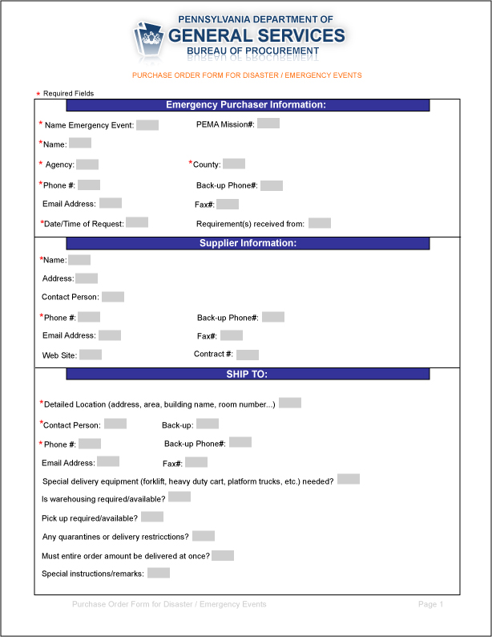

Emergency Purchaser Information:
(Used to identify and contact Purchaser.)

Supplier Information
(Provides details on supplier and contact info.)

Ship To:
(Provides details/instructions for deliveries.)

Item Information
(Purchase Order #, Priority, Description of
Desired Item, Quantity Needed)

Payment Method
(Indicate the preferred payment method.)
Approved By
(Approval polices, if required, will be set by PEMA or
the Eplo Agency Lead at the time of the event.)
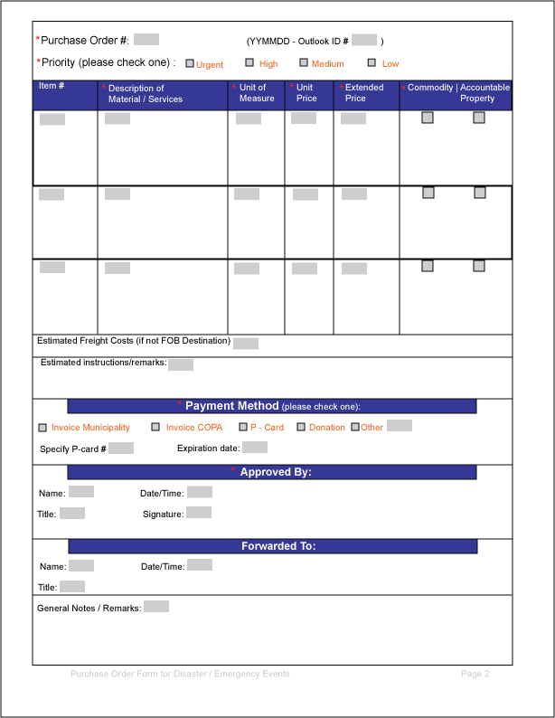Forwarded To
Forward To
(Use if forwarded to DGS/BOP POC)
General Notes
(Comments, instructions/information)

V. LIST OF PRE-QUALIFIED AND KNOWN SUPPLIERS

Purpose:

    - A separate List of Pre-Qualified and Known Suppliers for materials, services, raw materials and COSTARS are provided to Emergency Purchasers to assist them in finding vendors able to supply the goods/services needed.

    - Suppliers on these lists were contacted to provide additional emergency information. This information is available on the vCards provided. The vCards are electronic business cards that include emergency contact information such as cell phone numbers, back-up contact names and website addresses.

    - Links are also provided to search suppliers from federal contracts in GSA Schedules. These goods and services are available to any state or local government entity during and after an emergency.

    - In the event that the Emergency Purchaser is unable to find what is needed, or if the supplier cannot fulfill the need on the spreadsheets provided, use the DGS/BOP Points of Contact to notify someone who can assist. Access to this page is available only to CWOPA EPLO’s and that with User ID’s identified by PEMA/DGS.

The sections contained in the List of Pre-Qualified and Known Suppliers are:

- V. (A) Materials

- V. (B) Services

- V. (C) Raw Materials

- V. (D) COSTARS

- V. (E) GSA

V. (A) MATERIALS

Spreadsheet Contents:

- The Materials spreadsheet contains tangible supplies such as cots, blankets, water, batteries, shovels, latex gloves, rope, hydrogen peroxide, etc.

How to Use the Materials Spreadsheet:

- Click on the Materials section of the List Of Pre-Qualified And Known Suppliers (#3) on the Website Overview page.
- You will be asked whether you would like to open or save the document. Since internet access may become a factor during an emergency, it is recommended that you print your documents and/or SAVE them to your Desktop, to a Resource Account or a Thumb Drive whenever possible.
- Read the introductory page and then click “HERE” to access the spreadsheet that contains the Materials suppliers.

Description of Purchased Materials
2-Way Radios
Air horns

← DESCRIPTION OF PURCHASED MATERIALS COLUMN

- In the Description of Purchased Materials column, locate the item that is needed. The Materials are listed in alphabetical order. If you are having difficulty finding the material you need, use the Find tool Ctrl + F. (See Appendix B for help with the Find tool.)

Aloe vera
Analgesics
Antibacterial Ointment
Antibiotics
Axes
Baby formula
Bandage (16 pk)
Bandage (Ace)
Barrier Tape
Bathing soap (bar)
Batteries - 6V Lantern
Batteries - AA (24pk)
Batteries - AAA (18pk)
Batteries - C (12pk)
Batteries - D
Blackberries
Blanket
Blanket (Fire)
Rescue Blankets
Blower (portable)
Boots
Boots (Hip Waders)

Note: If you still cannot find the material you are searching for, you can try to locate a supplier on your own or contact one of the DGS/BOP Points of Contact for assistance.
← EMERGENCY TYPE COLUMNS

- The blue Emergency Type columns suggest which items may be useful during various types of emergencies. You can sort the spreadsheet by Type if desired. (See Appendix C for help with sorting cells.)

Emergency Type
Fire | Flood |  | Pandemic | Leased Pandemic
 | X |  | X
Contract Information
Contract Item? |  | Contract # |  |  |  | Lead Time  ← CONTRACT INFORMATION COLUMNS  - The next 3 columns provide Contract Information and include Contract #’s and normal lead times where applicable.  .
Yes |  | 4600009227 |  |  |  | 1-2 days
Yes
Yes
Yes |  | 4600009227 |  |  |  | 1-2 days
Yes |  | 4600008376 |  |  |  | 1-3 days
Yes |  | 4600011750 |  |  |  | 1-5days

Supplier
XPEDX
Grainger
McKesson
Grainger
McKesson
Grainger
XPEDX
Grainger

← SUPPLIER Name COLUMN

- In the green Supplier Name column, the supplier’s names are listed and many are connected to a hyperlink. These links take you to the supplier’s “vCard”, which provides additional emergency contact information. (See example below.)


Back

← vCARDS

- The vCards are electronic business cards that include emergency contact information such as cell phone numbers, back-up contact names and website addresses. This information should only be used during a disaster/emergency event.

EMERGENCY SUPPLIER CONTACT INFORMATION
Name of Supplier | Physician Sales & Service
Address (list any additional locations if applicable) | 22 Thicket Lane
. | Lancaster,Pa.17602
Main Office # | 717-394-3005
POC | Joy Lincoln
Phone # (if different) | 610-442-9443
Fax # | 717-394-6057
Email Address | jlincoln@pssd.com
Website | mypss.com
Contract # (if applicable) | 199684
Type of Business | Medical Supplies and Equipment
Hours of Operation
Emergency POC | 610-442-9443
Emergency Office Phone # | 800-909-2009
Emergency Cell Phone # | 610-442-9443
Emergency Blackberry #
Emergency Home Phone # | 717-394-3005
Emergency Fax # | 717-394-6057
Back-up Contact Information | Cathy Wary
 | 717-872-6889
Remarks

Supplier Information
Supplier | Supplier P/N or Mfg Name | Contract Price | Hyperlink | Supplier Contact | Supplier Tel # | Alternate | Alternate | COSTARS Contract(s)
XPEDX |  |  | http://www.xpedx.com | Rick Whitcomb | 1-800-321-1804
 |  |  |  |  |  | Wal-Mart | Home Depot | COSTARS-12
Grainger | 3U537 (24pk) | $ 26.90 | http://www.grainger.com/stateofpa | Sara Bower | 1-800-CALL-WWG | McKesson | XPEDX | COSTARS-11
McKesson |  |  | http://www.mckesson.com | Marsha Chevalier | 1-800-328-8111, ext. 6927 | Cardinal | PSS | COSTARS-11
↑ SUPPLIER INFORMATION COLUMNS

- Basic contact information can be found in the green columns on the right hand side of the spreadsheet.
- The columns to the right of Supplier named Supplier P/N or Mfg Name and Contract Price provide said information when it is available.
- Two Alternate suppliers are provided when known.
- When available, information on related COSTARS Contracts is provided in the last column.

- Use the supplier’s contact information on the spreadsheet and in the vCards to order items.

- Record all supplier contact/vCard information onto the “Supplier Information” portion of the Purchase Order Form.

- You may want to print the Materials Emergency Suppliers on legal sized paper to keep for reference or in the event that you loose connectivity to the web.

- Suppliers listed in Green are suppliers NOT ON CONTRACT with CWOPA (they are given as alternative supply sources).

- Items identified in Red should be considered as rental options (instead of purchasing).

- This is not an exhaustive list of suppliers. Many more may be able to assist.

- Record all supplier information, along with the Item #, the Description of the Material, the Unit of Measure, Unit Price and Extended Price (Unit of Measure multiplied by the Unit Price) in the Purchase Order Form.

Note: If you cannot find the material you are searching for on the spreadsheets, or if the supplier cannot fulfill your need, you can try to locate a supplier on your own or contact one of the DGS/BOP Points of Contact.
V. (B) SERVICES

Spreadsheet Contents:

- The Services spreadsheet identifies services such as portable showers, sanitation trailers, portable restrooms, excavating, dumpsters, catering, mold control, pumping services, mechanical contractors, food banks etc.

How to Use the Services Spreadsheet:

- Click on the Services section of the List Of Pre-Qualified And Known Suppliers (#3) on the Website Overview page.
- You will be asked whether you would like to open or save the document. Since internet access may become a factor during an emergency, it is recommended that you PRINT your documents and/or SAVE them to your Desktop, to a Resource Account or a Thumb Drive whenever possible.
- Read the introductory page and then click “HERE” to access the spreadsheet that contains the Services suppliers.

EMERGENCY SERVICES CATEGORIES:
← SERVICES CATEGORIES

- First, select the Services Category you need.

 | 1. Catering |  |  |  | 7. Mold
 | 2. Clean up |  |  |  | 8. Portable Restrooms
 | 3. Dumpsters |  |  |  | 9. Portable Shower - Sanitation
 | 4. Excavating |  |  |  | 10. Pumping
 | 5. Food Banks |  |  |  | 11. Roofing
 | 6. Mechanical Contractors

- Click on the Service you want.
- Service Categories can also be accessed from the tabs on the bottom of the spreadsheet.
- Clicking on the Service Category will bring up the spreadsheet for that particular Service.
- Each section lists a separate column for: Supplier Name, Address, City, County, State, Zip Code, Phone, Fax, Website and Email.
- You can sort the spreadsheet by Supplier Name, State, County, City, etc. to make it easier to locate a supplier for a specific area. (Detailed instructions for sorting are in Appendix D).
- You can also filter the spreadsheet by State and County to view suppliers located only in a specified area. (Detailed instructions on filtering can be found in Appendix E).

- If the supplier has a vCard (the supplier name is in blue font and underlined), click on the link for additional emergency contact information.

Back

EMERGENCY SUPPLIER CONTACT INFORMATION
Name of Supplier | Snyder & Mylin Excavating
Address (list any additional locations if applicable) | 1130 Lancaster Pike
. | Drumore, PA 17518  ← vCARDS  - The vCards are electronic business cards that include emergency contact information such as cell phone numbers, back-up contact names and website addresses. This information should only be used during a disaster/emergency event.
Main Office # | 717-284-0303
POC | Larry (Tim) Mylin
Phone # (if different)
Fax # | 717-284-0329
Email Address | Smexavating@aol.com
Website
Contract # (if applicable)
Type of Business | Excavating, Portable Toilets, Septic Pumping
Hours of Operation | Mon-Fri 6:30a.m. – 5:00p.m.
Emergency POC | Larry (Tim) Mylin
Emergency Office Phone # | 717-284-0303
Emergency Cell Phone # | 717-989-5832
Emergency Blackberry #
Emergency Home Phone # | 717-786-2275
Emergency Fax # | 717-284-0329
Back-up Contact Information | Ethan Mylin (717-989-5831) or
 | Matt Mylin (717-989-5833)
Remarks

- Record all supplier information, the Item #, the Description of the Service, the Unit of Measure, Unit Price, and Extended Price (Unit of Measure multiplied by the Unit Price), in the Purchase Order Form.

Note: If you cannot find the service you are searching for on the spreadsheets, or if the supplier cannot fulfill your need, you can try to locate a supplier on your own or contact one of the DGS/BOP Points of Contact.
V. (C) RAW MATERIALS

Spreadsheet Contents:

- The Raw Materials spreadsheet contains groups of suppliers that provide various raw materials such as propane, concrete, piping, chemicals, fuels, gases, etc.

How to Use the Raw Materials Spreadsheet:

- Click on the Raw Materials section of the List of Pre-Qualified and Known Suppliers (#3) on the Website Overview page.

- You will be asked whether you would like to open or save the document. Since internet access may become a factor during an emergency, it is recommended that you PRINT your documents and/or SAVE them to your Desktop, to a Resource Account or a Thumb Drive whenever possible.

- Read the introductory page and then click “HERE” to access the spreadsheet that contains the Raw Materials suppliers.

- Raw Materials are organized in material groups (Corrugated/Polyethylene Pipe, Chloride/Sodium, Fuel/Diesel, etc.) Search in the first column, called Material, for the group you want. If you are having difficulties finding the item you need, use the Find tool Ctrl + F. (See Appendix C for more information about the Find tool.)

- Listed for each material group are: Legacy #, SAP/SRM Contract #, the Commodity Specialist, Supplier Name, Location (City, State), a Contact Name, Emergency Telephone Numbers (office, cell, fax, home), a Website address where applicable, and a link to the supplier’s vCard where available.

- If the supplier has a vCard, the supplier name is in blue font and underlined. Click on the Supplier Name or use the tabs on the bottom of the spreadsheet to retrieve the information.

- This is not an exhaustive list of suppliers. Many more may be able to assist.

- Record all supplier information, along with the Item #, the Description of the Raw Material, the Unit of Measure, Unit Price, and Extended Price (Unit of Measure multiplied by the Unit Price), in the Purchase Order Form.

Note: If you cannot find the raw material you are searching for on the spreadsheets, or if the supplier cannot fulfill your need, you can try to locate a supplier on your own or contact one of the DGS/BOP Points of Contact.
V. (D) COSTARS

What is COSTARS?
- "COSTARS" is the Commonwealth of Pennsylvania's cooperative purchasing program. The COSTARS approach to cooperative purchasing uses the Commonwealth’s purchasing power to benefit local entities, leveraging purchasing power to obtain more competitive pricing than individual purchasers might be able to obtain on their own.
- COSTARS encourages the formulation of an interactive partnership between Local Public Procurement Units and the Commonwealth. The COSTARS Program provides local entities and suppliers a tool to find and do business with each other effectively through the use of a contract established by the Department of General Services. There are approximately 5,000 Local Public Procurement Units taking advantage of existing Commonwealth contracts.

Spreadsheet Contents:
- The COSTARS spreadsheet* contains cooperative contracts for Local Public Procurement Units in areas such as emergency responder loose supplies, toiletries, water and wastewater treatment consumables, janitorial supplies, material handling containers, etc.

How to Use the COSTARS Spreadsheet:

- Click on the COSTARS section of the List Of Pre-Qualified and Known Suppliers (#3) on the Website Overview page.
- Since internet access may become a factor during an emergency, it is recommended that you print your documents and/or SAVE them to your Desktop, to a Resource Account or a Thumb Drive whenever possible.
- Read the introductory page and then click “HERE” to access the spreadsheet that contains the COSTARS suppliers.
- Search in the left hand column, the Description of Purchased Materials column, for the item you want. If you are having difficulties finding the item you need, use the Find tool Ctrl + F. (See Appendix C for more information about the Find tool.)
- When you locate the needed item, go to the Contract # column and click on the contract number in the same row as the needed item.
- Review the suppliers provided in the contract area.
- If the supplier has a vCard, the supplier name is in blue font and underlined. Click on the link for additional emergency contact information.
- Record all supplier information, the Item #, the Description of the Material/Service, the Unit of Measure, Unit Price and Extended Price (Unit of Measure multiplied by the Unit Price) in the Purchase Order Form.

Note: If you cannot find the material/service you are searching for on the spreadsheets, or if the supplier cannot fulfill your need, you can try to locate a supplier on your own or contact one of the DGS/BOP Points of Contact.

* DUE TO LEGAL ISSUES, THIS SPREADSHEET CAN ONLY BE MADE AVAILABLE DURING AN ACTUAL DISASTER/EMERGENCY EVENT.
V. (E) GSA LINKS

Purpose:

- Under the US General Services Administration (GSA) Disaster Recovery Purchasing program, state and local governments may use the GSA Schedule to purchase a wide variety of products and services during and after an emergency event. Additionally, it can be used to locate a supplier of any type at any time. However, unless it is an official disaster/emergency situation and the supplier is identified with the icon, the supplier is not obligated or limited to charging the GSA negotiated rates.

When to Use GSA Links:
- The GSA Links page was created to supplement the other spreadsheets. The Bureau of Procurement has established relations with their own suppliers and it is recommended that Emergency Purchasers utilize those suppliers in order to get the Commonwealth’s negotiated prices.
- GSA schedules can be used at any time, but it is suggested to search and utilize the Commonwealth contracts first.
- GSA Schedules e-Library contains contact information for suppliers similar to the Commonwealth’s Disaster/Emergency Event vCards. As seen below, they also provide Terms & Conditions and other information on the contract the supplier has with GSA, along with the negotiated pricing.



  Contract #: | GS-07F-9308S
  Contractor: | MICROSEEPS INC
  Address: | 220 WILLIAM PITT WAY  PITTSBURGH, PA 15238-1328
  Phone: | (412)826-5245
  E-Mail: | dunrue@microseeps.com
  Web Address: | http://www.microseeps.com
  Socio-Economic : | Small business  Veteran Owned Small business
  Govt. Contracting Officer:
  BONNIE K. COOPER
  Phone: 817-574-2320
  E-Mail: bonnie.cooper@gsa.gov

Source | Title | Contract  Number | Contract Terms & Conditions | Contract End Date | Category |  | View Items Available
66 | SCIENTIFIC EQUIPMENT AND SERVICES | GS-07F-9308S |  | Jan 20, 2011
  873 2

Contents of the GSA Links page:
- Links directly to:
      - GSA Disaster Recovery Purchasing
      - GSA e-library
      - GSA Advantage
      - GSA Disaster Relief
      - Fleet Vehicles during an Emergency
      - Materials and Service specific to Pandemic Flu

- For instructions and an example of how to search for a supplier in GSA Advantage!, refer to Appendix F.
VI. POINTS OF CONTACT

Purpose:

- The DGS Bureau of Procurement Points of Contact page is created to assist Emergency Purchasers if there is difficulty finding a needed supplier/item during a disaster/emergency event. Access to this page is only open to CWOPA EPLO’s and those with User ID’s identified by PEMA/DGS.

When to Use DGS/Bureau of Procurement Points of Contact:

- The Points of Contact should only be used if an Emergency Purchaser is unable to find what is needed from the lists of suppliers provided, or if he/she is unable to contact a supplier that can meet the need (as shown on the Procurement Flow Chart.)
- Attempts should be made to contact the Bureau of Procurement Points of Contact first. They are the best source of expertise to assist. Failing that, contact any DGS EPLO or Subject Matter Expert on the list.
- Contact information contains name, title, work/home/cell/blackberry number and email address. (The example below blocks out personal information.)

- Joel Shiffler – DGS Agency EPLO; Materials
  - Work: 717-346-8179
  - Cell: 717-xxx-xxxx
  - Email: joshiffler@state.pa.us

- After contacting a DGS/BOP Point of Contact in a disaster/emergency event, the Emergency Purchaser should forward to the contact the information taken for the Purchase Order Form in progress.

NOTE: This information is private and confidential and will only be available during an actual disaster/emergency event.
VII. RELATED LINKS

Purpose:

- The Related Links page contains links to websites that deal with disasters/emergencies topics. They all provide information specific to a certain kind of disaster or help with the recovery process. These links are provided as a supplemental guide, giving reference to useful websites that often give more details and provide additional information and guidance regarding specific disaster/emergency events. All federal government sites are available in Spanish as well as English.

List of Related Websites:

- American Red Cross
- AvianFlu.gov
- Department of Health and Human Services
- Federal Emergency Management Agency (FEMA)
- GSA Advantage!
- GSA Disaster Recovery Purchasing Program
- National Center for Disease Control
- National Guard
- National Oceanic & Atmospheric Administration
- PA Department of Health
- PA Department of Homeland Security
- PA Department of Homeland Security PA Pandemic Flu Preparedness
- PandemicFlu.gov
- Pennsylvania Emergency Management Agency (PEMA)
- Ready.Gov
- State Emergency Registry of Volunteers (SERVPA)
- USA.Gov
- US Department of Homeland Security

Appendix

Appendix

APPENDIX A
HOW TO INSTALL DISASTER EMERGENCY WEBSITE ICON

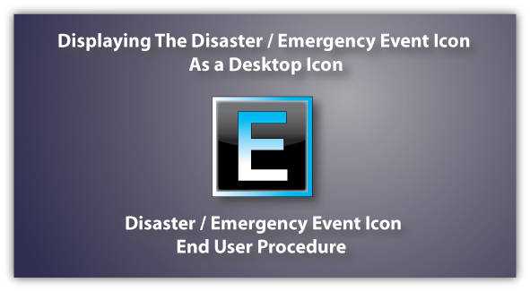

Appendix A-1
Created 10.24.2007

Step 1.
Please download and save the DisasterEmergencyEvent.ico file, that was sent to your E-mail address, to your desktop.
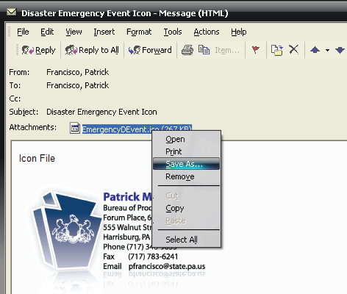

Step 2.
Go to the DGS homepage: www.dgs.state.pa.us and Log In with your CWOPA password or the password given to you after registering.

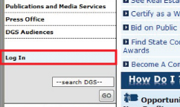

Appendix A-2
Step 3.
Select the procurement link at the top of the navigation bar on the right side of the screen, or go to: www.dgs.state.pa.us/procurement.

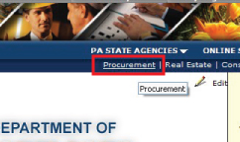

Step 4.
Select the Disaster / Emergency Event Community on the left side of the screen.
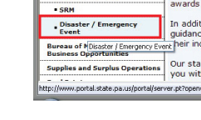
Step 5.
Once the Disaster / Emergency community has loaded select the Maximize button to reduce the size of your internet window. Your desktop should now be visible.
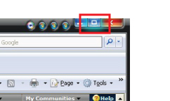
Appendix A-3
Step 6.
Click and drag the internet explorer page onto your desktop to create a shortcut to the Disaster / Emergency Event community.
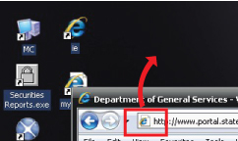

Step 7.
Once the shortcut has been created on your desktop you can now close your internet explorer window. Next you will want to right click on the newly created internet shortcut, and select properties from the menu.

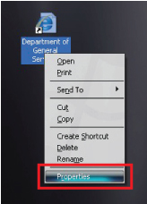

Appendix A-4
Step 8.
Next you will want to select the ‘Change Icon’ button in the middle of the screen under the Web Document tab.

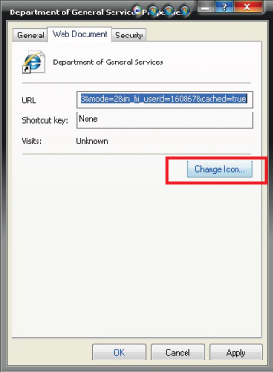

Step 9.
A new window appears, click browse, and you will want to select desktop from the list of locations on the left.
Appendix A-5
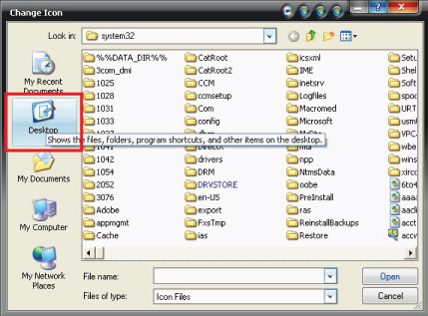

Step 10.
Select the Emergency Event .ICO (Icon) file that is located on your desktop.

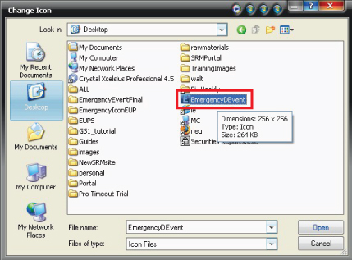
Appendix A-6
Step 11.
Next, a new Change Icon window will appear. You will want to select the Disaster Even Icon once again and select ‘OK’

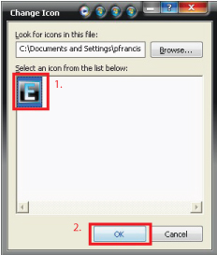

Step 12.
The Web Document window should now appear showing the Icon changed on the top left. From this window you will want to select ‘Apply’ and then ‘OK’ to confirm the icon change.
Appendix A-7
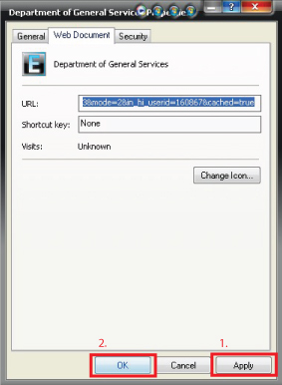

Step 13.
Now, you should have an icon on your desktop that looks like the one shown below.


Appendix A-8
APPENDIX B
Excel Spreadsheet Terminology

- Here are examples of Excel spreadsheet terms referred to in this User’s Guide.
Columns
Rows

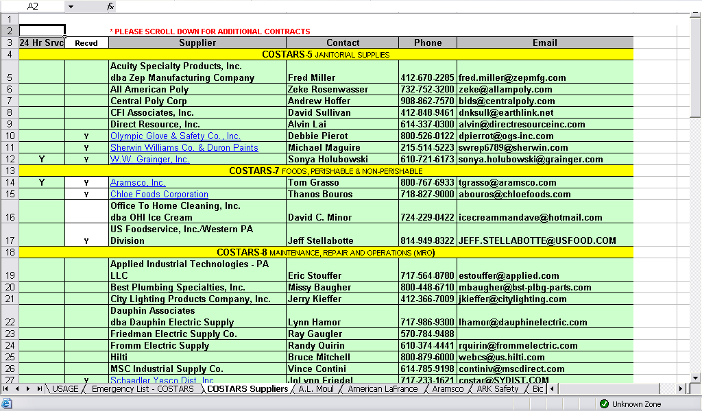

Scrollbars
Tabs
Tab Scrollbar

Appendix B-1
APPENDIX C
How to Use the Find Tool

- The Find tool can be used by holding down the Ctrl key and typing the letter F. This tool can also be accessed by going to Edit on the menu and clicking Find.
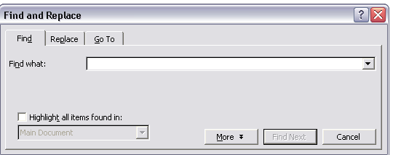

- Type the word you are searching for into the “Find what” field. Click the “Find Next” button to find the word in the document.
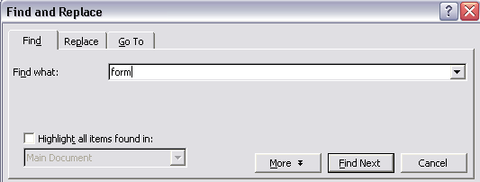

- The word will be highlighted in the text. To find more results, click the “Find Next” button again.
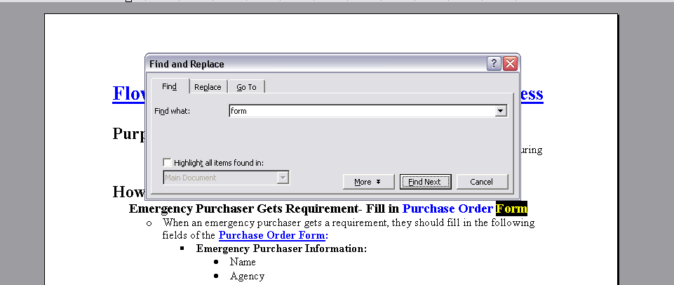

Appendix C-1
APPENDIX D
How to Sort Cells

- Highlight all of the data you want to sort (do not include the column headings).

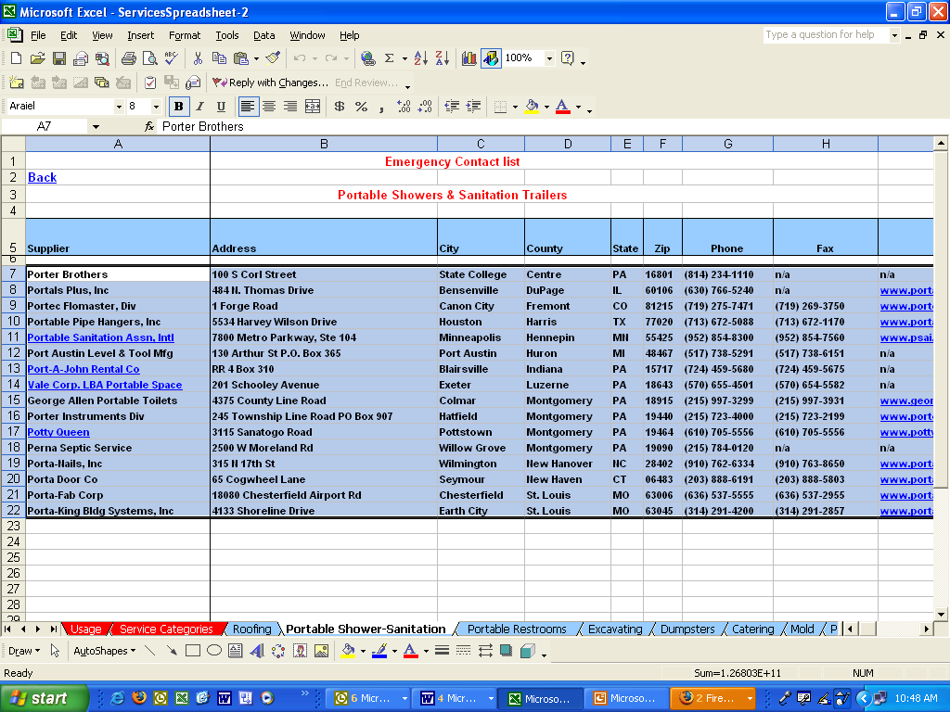

Appendix D-1
- On the Data menu, click Sort.

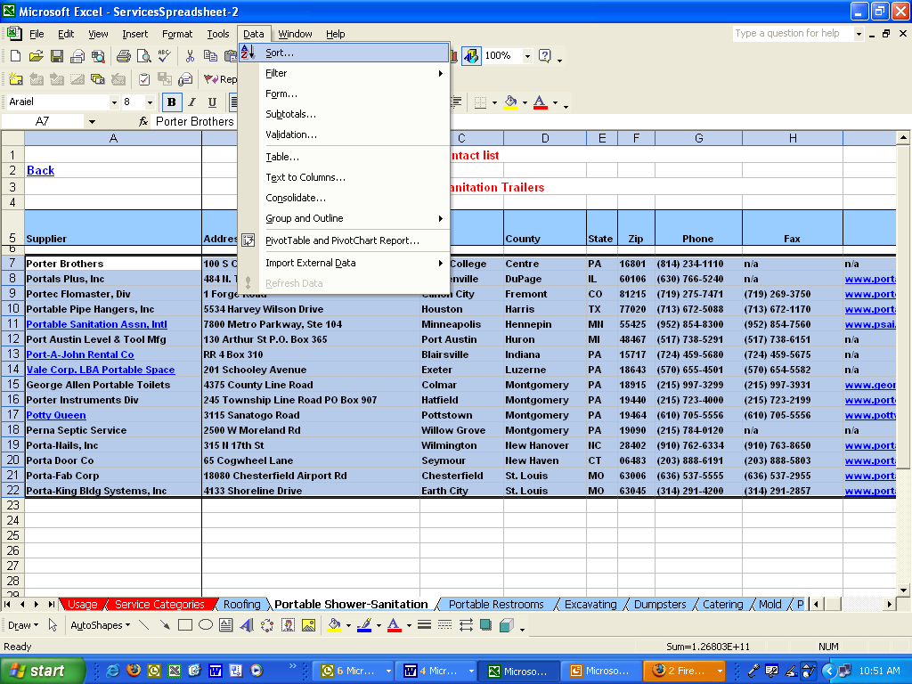

- A box will pop up with sorting options. The first drop down box will ask you what column you want to sort by. Select the Column letter you would like to sort by and choose whether you would like it to sort in ascending or descending order. You can sort by more than one field. Click OK when you are finished choosing your options.
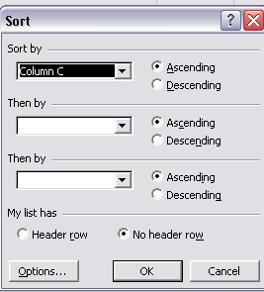

Appendix D-2

- The data is now sorted by Column C in alphabetic/numerical order.
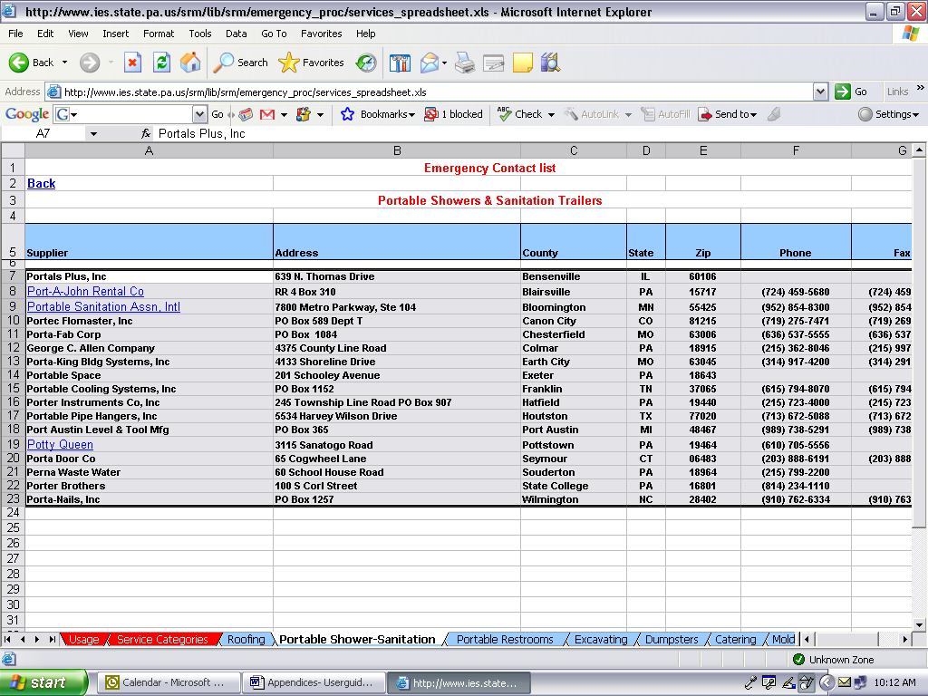

Appendix D-3
APPENDIX E
How to Filter Cells

- In order to narrow down the information in a table and eliminate the cells that do not contain the selected criteria, you can Filter the cells by highlighting the cells you would like to filter, including the column heading(s).
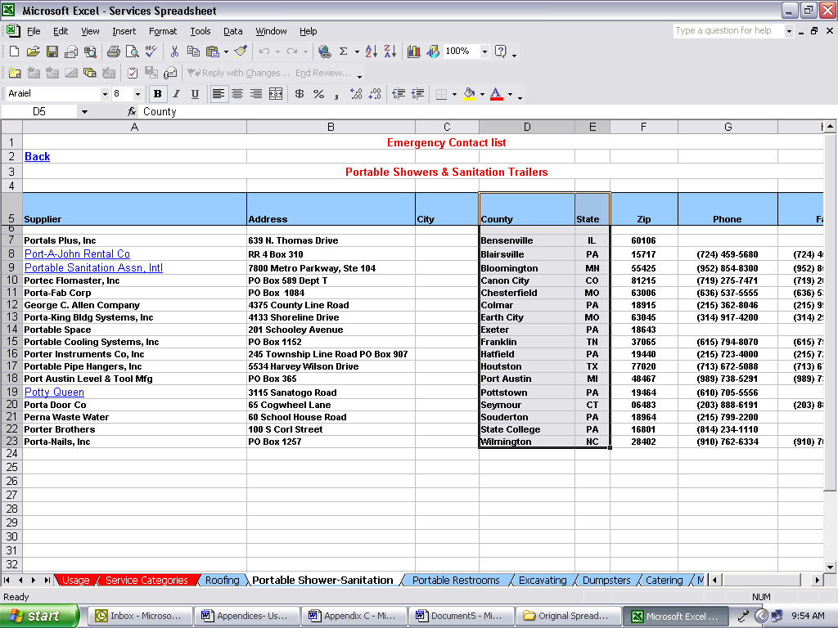

- Go to Data-> Filter-> select Autofilter

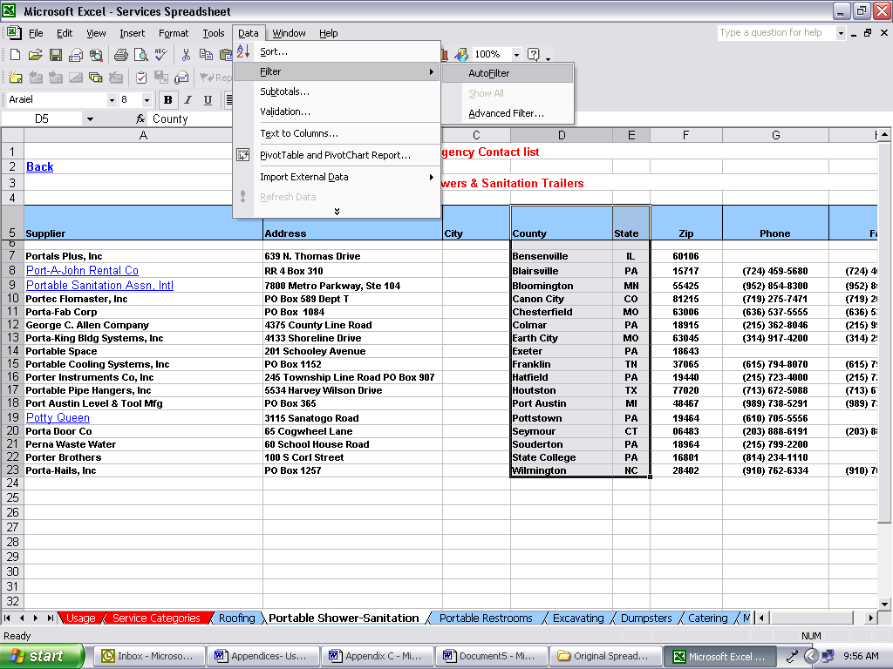

Appendix E-1
- There is now a gray dropdown box in the cell heading(s) on the right hand side.

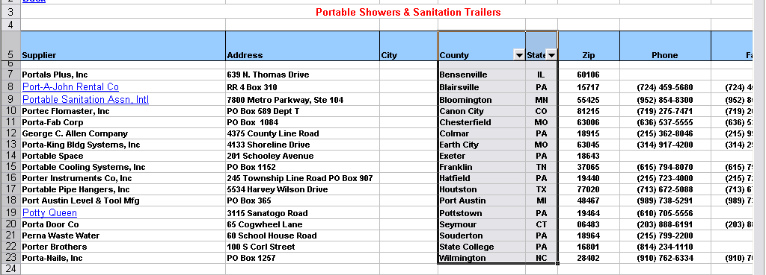

- Click on the dropdown box. All of the entries in the column’s cells are listed in alphabetical order.

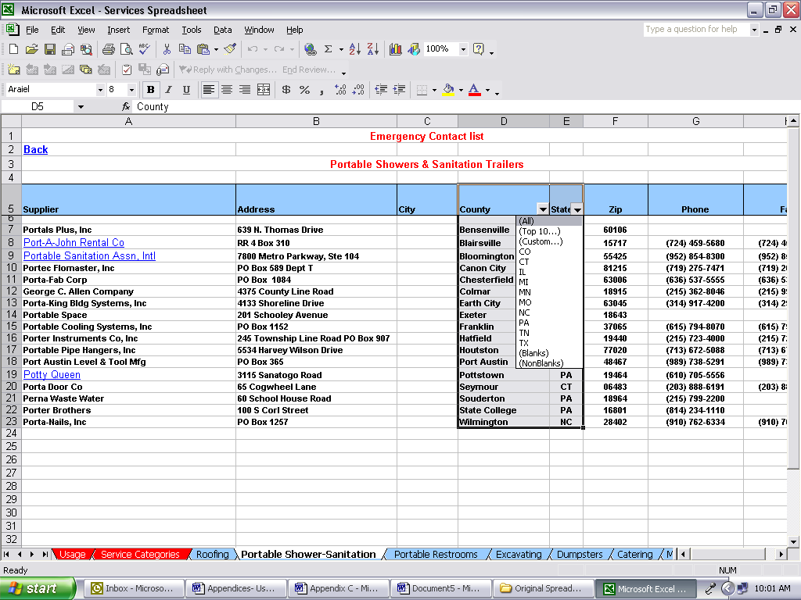

- Select the information you would like to view. In this example we are going to select PA in order to only view suppliers from Pennsylvania. If you would like to further narrow the results, filter other columns as well.

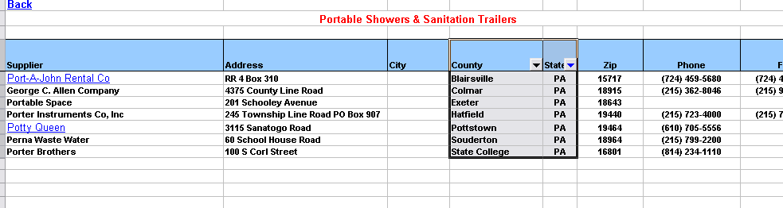

Appendix E-2
- If you would like to restart and view all of the data (states), click on the gray dropdown box again and select “All”.
Appendix E-1

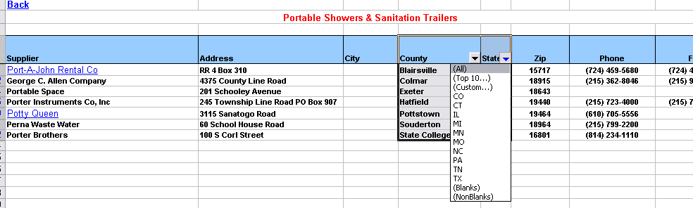

Appendix E-3
APPENDIX F
How to Search in GSA Schedules
Example: How to Purchase Water

- Go to www.gsa.gov/disasterrecovery

- Select the “Schedules e-Library” link
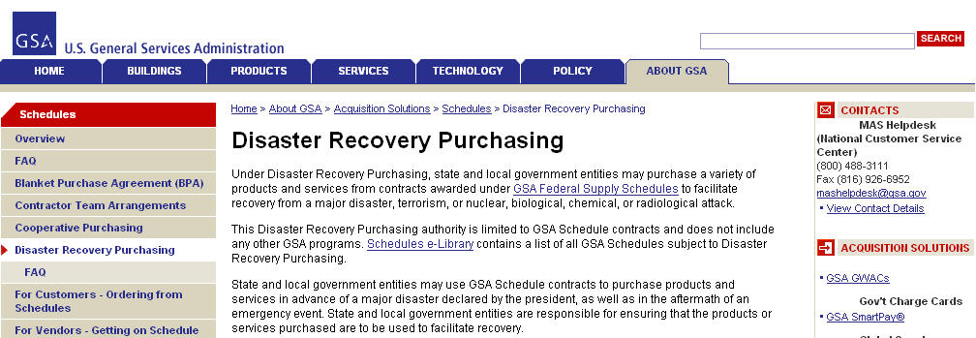

- On the right hand side of the page under “Disaster Recovery Purchasing”, click on the “View participating vendors” link.

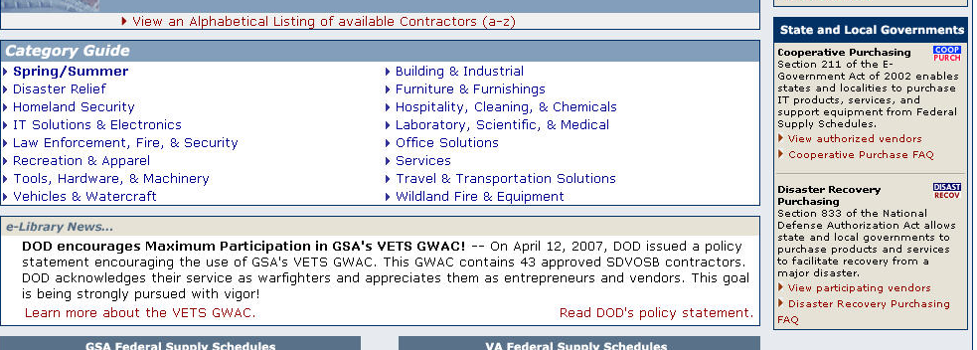
Appendix F-1
Search under the “Description” column for the type of item you are looking to purchase and click on the corresponding number (in this case, #73, FOOD SERVICE, HOSPITALITY, CLEANING EQUIPMENT AND SUPPLIES, CHEMICALS AND SERVICES).
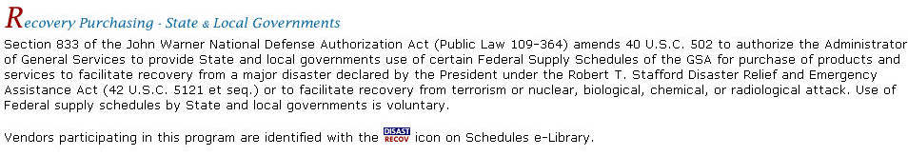

- Under the “Category” column, select the category that includes the item that you are looking for. This will enable you to view the procurement contractors for this product. (In this case, we would select 302 2 Emergency and Non-Emergency Food Service Support because this lists potable water in the description.)
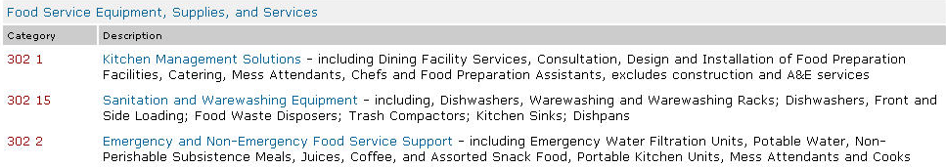

- If necessary, click on the (Sort by) link above the “City, State” column to organize contractors by state for easy recognition of the Pennsylvania contractors.
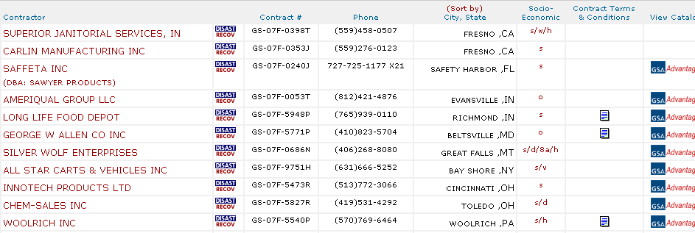

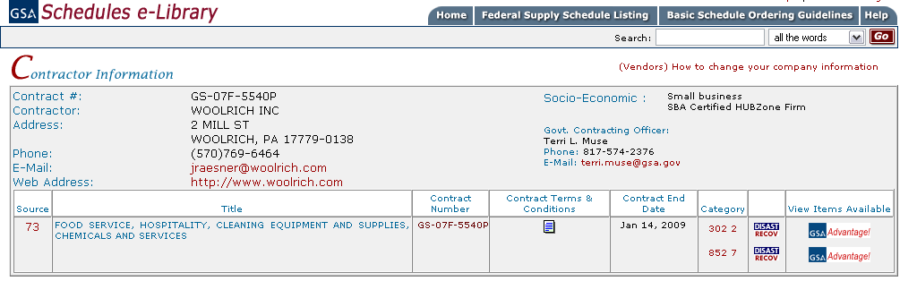
- Click on the contractor’s name to get contact (V-Card) information. Save this page for later use.
Appendix F-2
- When available, review and print the contract terms and conditions.

After obtaining the contact and contract information, click on the icon on the same row as the contractor’s name to view items available by that contractor. To ensure that the items purchased can be used for Disaster Recovery, make sure there is a icon following the name of the contractor. (In this example, the only PA supplier is Woolrich Inc.)

IF YOU WOULD LIKE TO VIEW OTHER TYPES OF GOODS SUPPLIED BY A CONTRACTOR: click on the name of the desired contractor. If searching for Disaster Recovery items, make sure that the icon is listed after the name of the desired contractor.

- Once you decide which product best suits your needs, enter the quantity desired in the right column (in this example, quantity of cases each case containing 24/ 25 oz bottles).
After entering the quantity click on the  icon. (2000 cases of the 25oz Woolrich Spring Water)

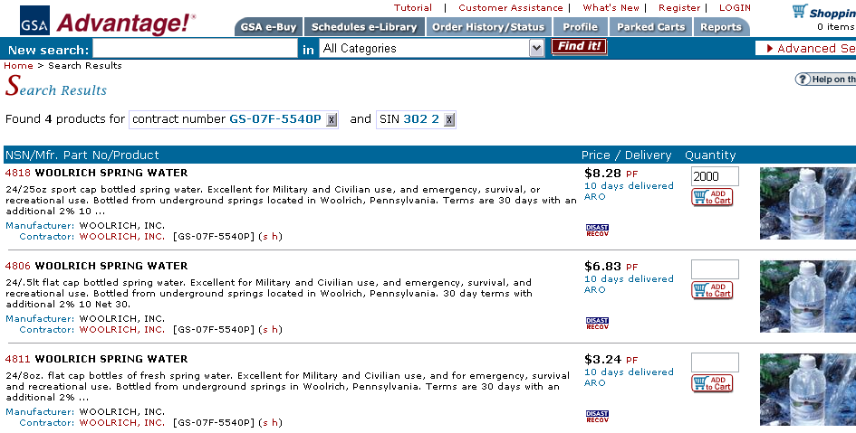
Appendix F-3
Your current shopping cart will list the description of the items you have selected, the quantity of each item, the unit price, and the total price of your order.

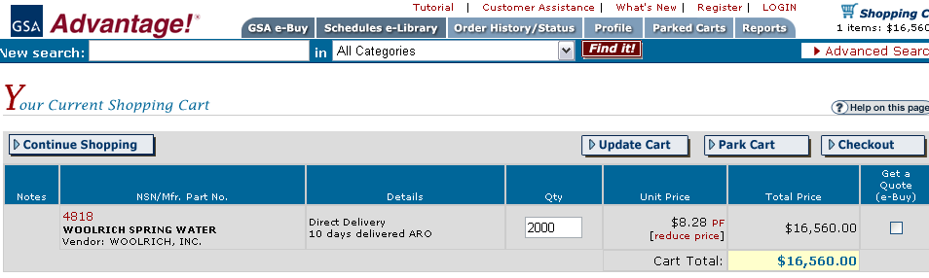

You may receive a warning box stating: Item is FOB ORIGIN "FOB Origin" means that the price shown does not include cost of shipment from the vendor to your location. Additional charges for transportation will be added by the vendor. Click on the red words in the warning for more information concerning FOB.
  - To continue shopping select the icon in the upper left of the page. Select the additional goods you would like to buy then proceed to checkout.
  - If you are finished shopping, print and save the page displaying the items in the shopping cart that you would like to purchase (you will need this information for the PURCHASE ORDER FORM).

- Complete PURCHASE ORDER FORM on the Disaster Emergency Procurement website.

- Once you find the items you need and complete the PURCHASE ORDER FORM, proceed to the next step in the Disaster Emergency Procurement flow chart which is to contact the supplier.
Appendix F-4
PURCHASE ORDER FORM FOR DISASTER / EMERGENCY EVENTS
* Required Fields
Emergency Purchaser Information:

*Name of Emergency Event: PEMA Mission #:
*Name:

*Agency: *County:

*Phone #: Back-up Phone #:

Email Address: Fax #:

*Date/Time of Request: Requirement(s) received from:

Supplier Information:

*Name:

Address:

Contact Person:

*Phone #: Back-up Phone #:

Email Address: Fax #:
Web Site: Contract #:

SHIP TO:

*Detailed Location (address, area, building name, room number…)

*Contact Person: Back-up:

*Phone #: Back-up Phone #:

Email Address: Fax #:

Special delivery equipment (forklift, heavy duty cart, platform trucks, etc.) needed?

Is warehousing required/available?

Pick up required/available?

Any quarantines or delivery restrictions?

Must entire order amount be delivered at once?

Special instructions/remarks.
*Purchase Order #: (YYMMDD - Outlook ID- # )

*Priority (please check one) : Urgent High Medium Low

Item # | *Description of  Material / Service | *Unit of  Measure | *Unit  Price | *Extended  Price | *Commodity | Accountable  Property
Estimated Freight Costs (if not FOB Destination)
Special instructions/remarks:

*Payment Method (please check one):

Invoice Municipality Invoice COPA P-Card Donation Other

Specify P-card # Expiration date:

*Approved By:

Name: Date/Time:

Title: Signature:

Forwarded To:

Name: Date/Time:

Title:
General Notes / Remarks:

