How to Search in GSA Schedules
Example: how to purchase water

- Go to www.gsa.gov/disasterrecovery

- Select the “Schedules e-Library” link
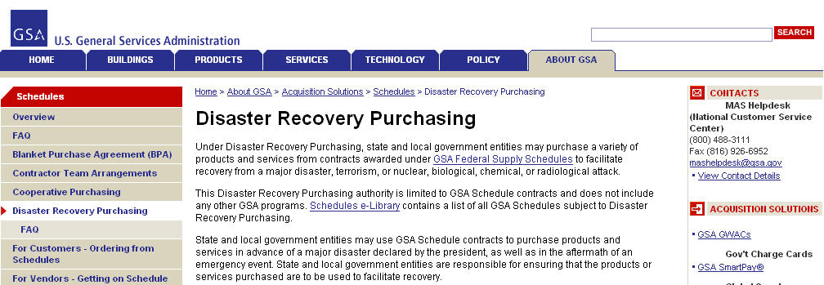

- On the right hand side of the page under “Disaster Recovery Purchasing”, click on the “View participating vendors” link.

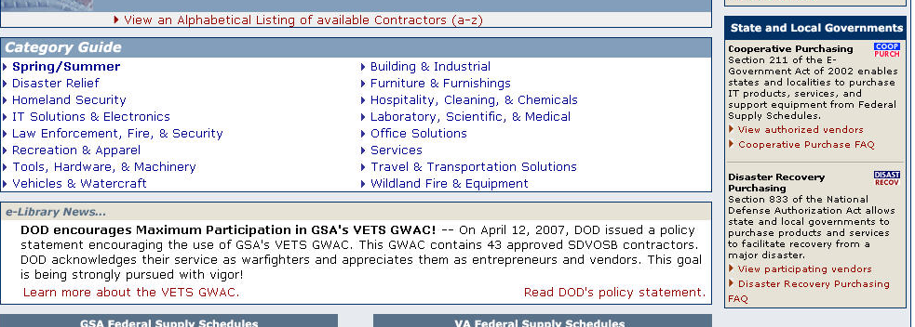
- Search under the “Description” column for the type of item you are looking to purchase and click on the corresponding number (in this case, #73, FOOD SERVICE, HOSPITALITY, CLEANING EQUIPMENT AND SUPPLIES, CHEMICALS AND SERVICES).
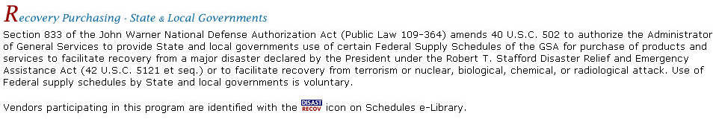

- Under the “Category” column, select the category that includes the item that you are looking for. This will enable you to view the procurement contractors for this product. (In this case, we would select 302 2 Emergency and Non-Emergency Food Service Support because this lists potable water in the description.)
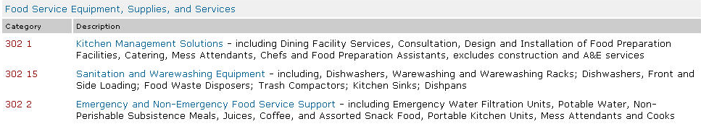

- If necessary, click on the (Sort by) link above the “City, State” column to organize contractors by state for easy recognition of the Pennsylvania contractors.
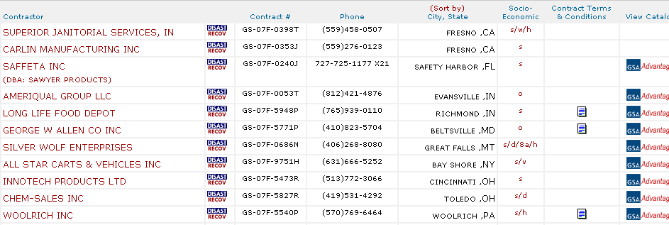

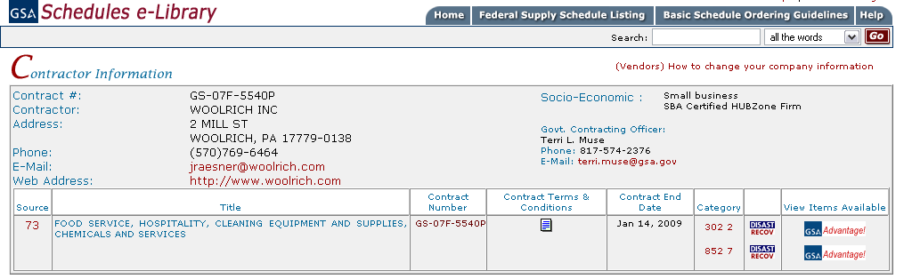
- Click on the contractor’s name to get contact (V-Card) information. Save this page for later use.
- When available, review and print the contract terms and conditions.

After obtaining the contact and contract information, click on the icon on the same row as the contractor’s name to view items available by that contractor. To ensure that the items purchased can be used for Disaster Recovery, make sure there is a icon following the name of the contractor. (In this example, the only PA supplier is Woolrich Inc.)
IF YOU WOULD LIKE TO VIEW OTHER TYPES OF GOODS SUPPLIED BY A CONTRACTOR: click on the name of the desired contractor. If searching for Disaster Recovery items, make sure that the icon is listed after the name of the desired contractor.

- Once you decide which product best suits your needs, enter the quantity desired in the right column (in this example, quantity of cases each case containing 24/ 25 oz bottles).
After entering the quantity click on the  icon. (2000 cases of the 25oz Woolrich Spring Water)

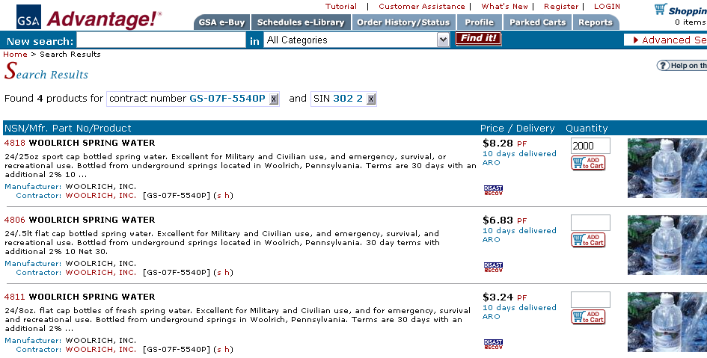

- Your current shopping cart will list the description of the items you have selected, the quantity of each item, the unit price, and the total price of your order.
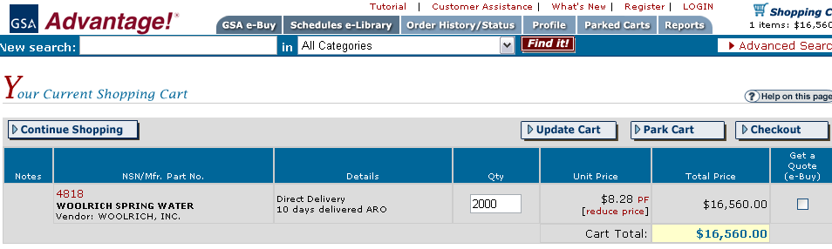

You may receive a warning box stating: Item is FOB ORIGIN "FOB Origin" means that the price shown does not include cost of shipment from the vendor to your location. Additional charges for transportation will be added by the vendor. Click on the red words in the warning for more information concerning FOB.
  - To continue shopping select the icon in the upper left of the page. Select the additional goods you would like to buy then proceed to checkout.
  - If you are finished shopping, print and save the page displaying the items in the shopping cart that you would like to purchase (you will need this information for the PURCHASE ORDER FORM).

- Complete PURCHASE ORDER FORM on the Governor Declared Emergency Procurement website.

- Once you find the items you need and complete the PURCHASE ORDER FORM, proceed to the next step in the Emergency Procurement flow chart which is to contact the supplier.

